**ECE 4950 Project 1**

**Group 13**

**Valerie Moran, Brandon Cuttino, Ben Liggett, Sarah Anderson, and Rocky Aho**

**28 September 2020**

**Executive Summary:**

The goal of this project was to design a circuit that used a potentiometer, which was our sensor of choice, to control the voltage supplied to an electromagnet. When the supplied voltage is above a certain threshold, the magnet is energized and can pick up metallic items. When the supplied voltage is below the threshold, the magnet is de-energized and drops whatever it is holding, losing the ability to pick it or anything else up. We set our threshold to 2.5 Volts because it is half of the maximum voltage for our circuit. In addition to creating a working circuit, we were also able to learn and implement the AutoCAD and Simulink software platforms. We used AutoCAD to create a design that can be laser etched, and we used Simulink to write the logic for our circuit. Overall, our project was successful. We were able to implement all of the desired parts in our circuit while still achieving our goal of using the electromagnet to pick up metallic objects when the voltage is above the specified threshold. Lastly, we were able to create a 4”x4” laser etched design that is specific to our group.

**Materials and Methods:**

Part List:

* Matlab 2020a with Simulink
* Arduino Mega 2560
* 3 Prong 10kΩ Potentiometer
* Jumper Cables
* Breadboard
* L293D Motor Driver Chip
* 5V 2.5kg Electromagnet
* 1N4004 Diode

Before connecting the hardware components, we designed and built the Simulink model. Using Matlab version 2020a, we built the model shown in **Figure 1**.

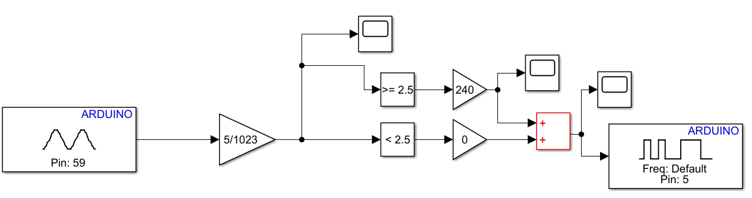

**Figure 1**: **Simulink Model for adjusting the duty cycle of an Electromagnet**

To begin, we first used an analog input block set to pin 59, or A5. The analog-to-digital converter within the Arduino sets the input voltage between a range of 0 to 1023. To adjust the range for our desired voltages, the value from this pin was then adjusted using a gain block, such that the value was between 0V to 5V. After adjusting the input value, we then compared this adjusted value to see if it was greater than equal to or less than a threshold value, where the threshold was set to 2.5V. If the adjusted input was greater than or equal to the threshold, then the input value to the pulse width modulator (PWM) was set to 240, where a value of 240 will create a 94% duty cycle. This value can be adjusted to decrease or increase the magnet's strength. If the adjusted input was less than the threshold, the input value to the pulse width modulator was set to 0, where the duty cycle will also be 0. Both logic lines are fed into an addition block. This is done so that they feed into a single PWM output block, with an output pin set to pin 5.

After building the simulink model, the hardware components were wired as shown in **Figure 2**.

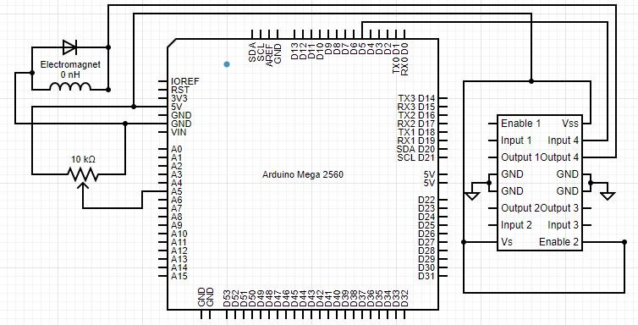

**Figure 2: Hardware Wiring Diagram**

The first connections were from the Arduino’s 5V pin and ground pin. These were connected to the buses of the breadboard. Next, 5V was connected to the high side of a potentiometer, and the low side was connected to ground. The output of the potentiometer was connected to pin 59, or A5, of the Arduino. Next, the L293D motor driver was connected. For the L293D motor driver chip, pins 8, 9, and 16 were connected to 5 volts outputted from the Arduino. Pins 4, 5, 12, and 13 were connected to the ground bus. Pin 15 (input 4) was connected to the PWM pin D5 from the Arduino. The Arduino provided a PWM signal to pin 15, and pin 14 was the output of the chip. Pin 14 was connected to the 1N4004 diode’s cathode and one leg of the electromagnet. The second wire of the electromagnet was connected to the anode of the diode, and both were connected to ground. This completed the wiring of the system.

**Results:**

Once having completed the assembly of the hardware and software, the tests were undertaken. As shown in **Figure 3,** the potentiometer was first slowly turned to increase the input voltage, starting at 0 volts and going up and ending at 5 volts. The potentiometer was then turned down slowly to a voltage of just under 2.5 volts. The voltage was then once again slowly raised to a value of little more than 4 volts to then be slowly turned back down once more to just under 2.5 volts. Finally the voltage was brought back up to just over 2.5 volts where it stayed until the end of the test at 50 seconds. The resulting voltage input and corresponding output to the motor drive chip appear below.

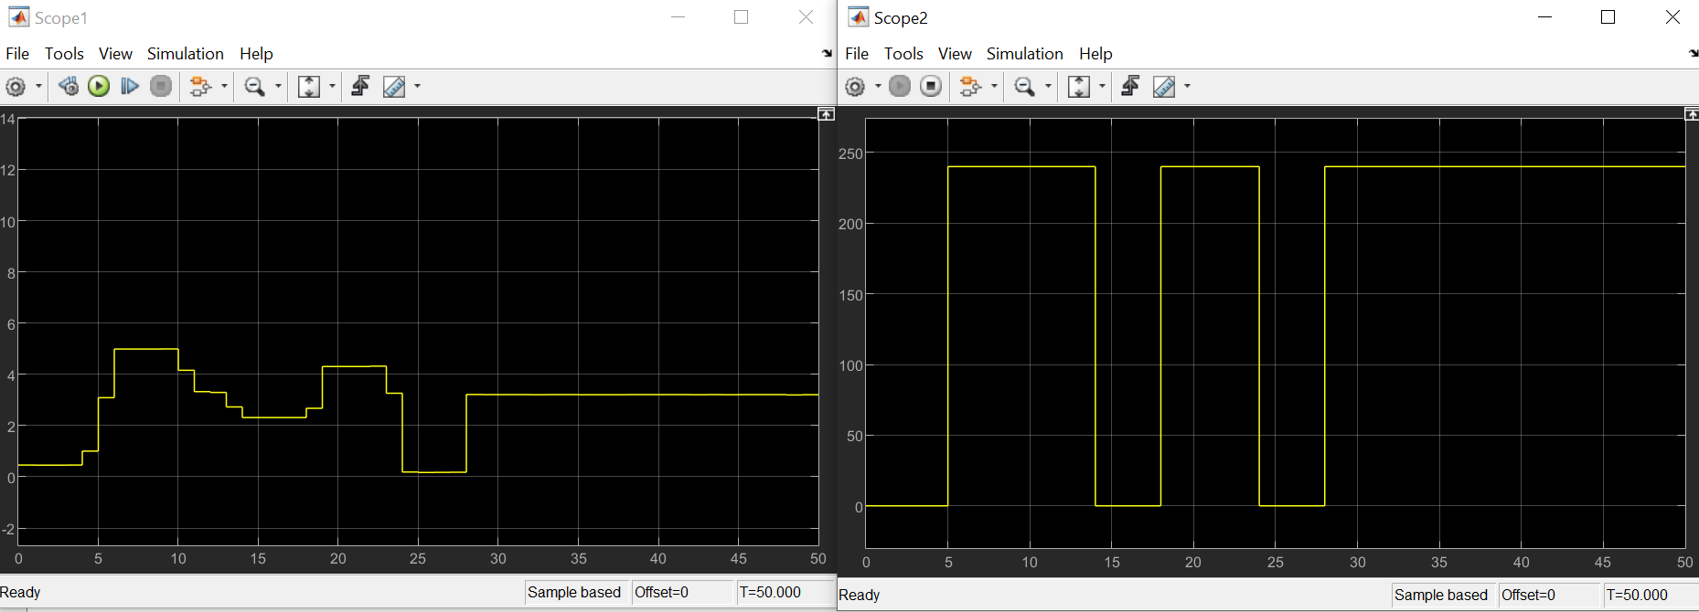

**Figure 3: Input Voltage (left) and Output PWM signal (right) for an adjusted Potentiometer Value**

During the test, the electromagnet powered on, and was able to lift a wrench, during the intervals, shown in **Figure 3**, of 5-15 seconds, 17-24 seconds, and finally staying on during the interval from 28-50 seconds when the test ended.

**Discussion:**

At roughly the times of 5, 15, 20, 24, and 28 seconds, where the input voltage decreases/increases from a value either slightly above/below 2.5 volts, the output signal changes. **Table 1** below summarizes this idea as well as indicates the output before and after a change, and whether the magnet was charged.

**Table 1: Comparing the Input and Output**

|  |  |  |  |  |  |
| --- | --- | --- | --- | --- | --- |
| Time (T) [seconds] | 5 | 15 | 20 | 24 | 28 |
| Input before T | 1.30 | 2.50 | 2.30 | 2.60 | 0 |
| Input after T | 2.60 | 2.0 | 4.10 | 0 | 2.70 |
| Output after T | 0 | 244 | 0 | 244 | 0 |
| Output after T | 244 | 0 | 244 | 0 | 244 |
| Magnet charged after T? | yes | no | yes | no | yes |

What these results indicate is that as the input voltage is increased past the value of 2.5 volts, the output will change to 244. Conversely, as the input voltage is decreased below the value of 2.5 volts, the output will go back to 0. This corresponds to the fact the board was programmed to output a signal of 244 when the input voltage from the potentiometer was equal to or greater than the value of 2.5, which was the set threshold.

The second important fact that this chart reveals, is that when the output signal was set to 244, by the voltage going above 2.5 volts, the magnet powered on. Also correspondingly, as the output goes to 0, when the input voltage falls below 2.5 volts, the magnet powered off.

What this shows overall then is that as the voltage goes above or is equal to 2.5 volts the magnet will power on, and when it goes below 2.5 volts the magnet will power off. This was the major design goal for this project. Exemplifying the idea that the equipment has and is functioning correctly.

**Conclusion:**

The purpose of this project was to use an analog sensor to control an electromagnet and to get familiar with AutoCAD by producing a small 4”x4” laser etched design to show its ability as a prototyping tool. For Part 1 of this project, selecting an analog sensor, we chose a potentiometer because we felt that it was the easiest way to adjust an input voltage. We chose a threshold of 2.5V because that was exactly half of the highest potential voltage. The threshold can be set to any voltage between 0 and 5V within Simulink. We chose to use the motor driver chip because we felt like it would be useful in future projects. Using the motor driver chip allows the electromagnet to be energized at different strengths depending on the thresholds and duty cycle. For example, we can have three different thresholds for three different strengths (corresponding to three different duty cycles). We chose a duty cycle of 240 because it is 94% of the maximum and we didn't want to burn out any of our parts. A higher duty cycle corresponds with a more energized electromagnet, and a lower duty cycle corresponds to a less energized electromagnet. Simulink was a learning process for us since none of us had used it before. We had the most difficulty using Simulink when determining why certain things were happening. For example, we would have the graphs of the analog input voltage to the Arduino be way higher than expected (i.e. 1000), but after further research, we found that if it was an analog input pin it had to be scaled by 1023. We would generally say that these parts could be used in a larger robot control project because they were relatively easy to use and quite cheap in cost. One limitation to these parts is the max voltage that can be used. The maximum voltage on the Arduino is 5V so if anything needed a higher voltage, and external power supply would be needed. AutoCAD was used to create the small etched acrylic part. We created the outline of South Carolina with the Palmetto tree etched in the middle. We originally created the outline, but it was the wrong scale and it was way too big. We had to figure out how to change the scale of the outline so that when we etched it, it was the correct size. The possible uses of the laser cutter in future projects are using it to create a mountable case for the Aurdino and to cut out parts for the final project (i.e. arms to hold the camera, mounts for motors and breadboards, etc.). We feel like the laser cutter will be used more for future projects because it can help us organize and create different parts that weren’t supplied to us. Overall, this project was very helpful to learn how to use Simulink, using an analog sensor to control an electromagnet, and how to use AutoCAD to etch and cut out acrylic designs. The things that we learned in this project will and can be used in future projects.

**References:**

[1] Arduino, Somerville, MA, USA. *Analog Read Serial.* (2018). Accessed: Sep. 27, 2020. [Online]. Available:<https://www.arduino.cc/en/Tutorial/BuiltInExamples/ReadAnalogVoltage>

[2] STMicroelectronics, *L293D L293DD Push-Pull Four Channel Driver with Diodes,* L293D Datasheet, July 2003.

# **ECE 4950 Project 1 – Research Report Rubric**

Group Member Last Names: Aho, Anderson, Cuttino. Liggett, and Moran

|  |  |  |  |
| --- | --- | --- | --- |
| Score | Pts |  | Perfor mance Indicat  ors |
|  | 15 | **General Format - Professional Looking Document/Preparation (whole document)**   1. Fonts, margins (11pt, times new roman, single spaced. 1" margins on all sides). 2. Spelling and grammar are correct 3. Layout of pictures – all figures need numbers and captions and must be referenced in the text 4. Follows the page limitations below. 5. References (if any). Use IEEE reference format. 6. This grading sheet is included as the final page. | g.1 |
|  | 20 | **Page 1: Title, Group Name, Group Members, and Date Executive Summary** (~1/3 of the page)  Provide a brief summary of the whole experiment. Use language that targets **a non- technical audience**. An important skill for an engineer is to communicate complex technical information to a general audience that may be involved in decision making,  e.g. marketing. Important criteria:   * 1. Can a non-technical audience (~ high-school degree) read this section and understand your goals, procedures, and conclusions?   2. Use simple words and graphics to help explain | g.1 |
|  | 40 | The next sections of the report follow the standard **laboratory report format**.  **Page 2: Materials and Methods for the Sensor/Actuator Experiments (don’t need to describe the laser cutter)** (< 1 page)  You are establishing the credibility and usefulness of your results by providing all the details so that someone else could repeat your experiment. As an example, MATLAB 2011a may behave differently than MATLAB 2010b – the software version information which would be required to reproduce your result should be included. This section should answer the following:   1. What equipment is used (i.e. real-time workstation), include software versions. 2. How were the experiments conducted? How is the equipment connected and used? Describe the instrumentation, special cables (if any), connections, and experiments using diagrams and photos.   **Pages 3-4: Results and Discussion for the Sensor/Actuator Experiments** (< 2 pages) Describe what you have done. Include plots for all the experiments and a brief discussion of how you interpret the results. Did you demonstrate (through your documentation) that the equipment has been configured and used correctly?  **Page 5: Conclusions and References** (< 1 page)   1. Based on this experiment, do you recommend this equipment for use in a robot control project? What are the possible limitations? Your results and   observations should be the basis for your conclusions. (~1/2 page)   1. What are the possible uses for the laser cutter in your projects? (~1/4 page) | k.2  k.2  k.2 |
|  | 5 | **Page 6: This Grading Sheet** | g.1 |
|  | 20 | **Laser Cut Part File** Grading based on:   1. How well does this part demonstrate the capability of the laser cutter to make prototype parts for an automated (robotic) system? 2. Originality and creativity | k.2  i.1 |